RECEIPT AND INVOICE DIGITIZER
A Smart System for Receipt and Invoice Text Extraction
Milestone-1: Document Ingestion & OCR Pipeline
Goal: Convert paper receipts/invoices into searchable digital records using OCR.

2.TABLE OF CONTENTS

S.No | Content Title
1 | Title Page
2 | Contents Page
3 | Problem Statement
4 | Modules (Milestone-1)
5 | Technologies Used
6 | Architecture
7 | System Components
8 | Process Flow
9 | Database Schema (SQLite)
10 | Validation & Duplicate Detection
11 | Output Screens
12 | References

3.PROBLEM STATEMENT
In many organizations and for individuals, receipts and invoices are still handled in paper form. These documents are often:
- Easily lost or damaged
- Difficult to organize and search
- Manually entered into systems (slow + error-prone)
- Not suitable for analytics and automated bookkeeping

Project Goal
The goal of this project is to build an automated system that can:
- Accept receipt/invoice uploads in image/PDF formats
- Enhance document images using preprocessing
- Extract text using OCR
- Convert extracted text into digital structured records stored in a database

Milestone-1 Scope (as implemented in code)
Milestone-1 focuses on the first phase of the pipeline:
- Upload receipt/invoice files (JPG, PNG, JPEG, PDF)
- Convert PDFs into images using PyMuPDF
- Apply preprocessing (denoise, threshold, morphology) with user controls
- Extract raw OCR text using Tesseract
- Convert raw OCR into structured values (invoice id, vendor, items, total)
- Save structured data into SQLite database (vault.db)
- View results in Dashboard + History pages

4 . MODULES
4.1 Document Ingestion Module
Objective: Allow users to upload receipt/invoice images and PDFs.
Implementation:
- Streamlit file uploader accepts:
  - .png, .jpg, .jpeg, .pdf
- For PDF:
  - Convert PDF pages into images using PyMuPDF (fitz)
  - If multi-page: user selects page using a slider
  - Selected page becomes input for preprocessing + OCR
Key Functions:
- Upload interface with drag/drop
- PDF page extraction
- Page selection for multi-page invoices

4.2 Image Preprocessing Module
Objective: Enhance document quality and improve OCR accuracy.
Implementation :
Preprocessing pipeline implemented using OpenCV:
- Resize image for OCR readability
- Convert to grayscale
- Apply CLAHE for contrast enhancement
- Denoise using fastNlMeansDenoising
- Adaptive Thresholding (Gaussian method)
- Morphological opening to remove noise
User Controls:
- Denoise strength slider
- Adaptive block size slider
- C-value slider
Output:
- UI shows:
  - Original image
  - Processed image side-by-side
4.3 OCR & Raw Text Extraction Module
Objective: Convert cleaned image into raw machine-readable text.
Implementation:
- OCR performed using Tesseract
- OCR configuration used:
  - --oem 3 (default engine)
  - --psm 6 (single uniform block of text)
Output:
- Extracted raw text used for:
  - Total detection
  - Tax detection
  - Vendor name extraction
  - Structured record building

4.4 Structured Extraction Module
Objective: Convert raw OCR text into structured JSON-like record.
Implementation:
Two extraction modes:
- ✅ Gemini Extraction (optional)
  - gemini_extract_structured() sends OCR text to Gemini model
  - Gemini returns strict JSON format:
    - vendor_name, date, items[], total_amount, currency, tax
  - Items are cleaned using rules (clean_items())
- ✅ Fallback Regex Extraction
  - If Gemini quota exceeded / disabled:
    - vendor = first meaningful line
    - total extracted using keyword search + regex
    - tax extracted using GST/VAT patterns

4.5 Storage & Analytics Module
Objective: Store results and allow user to view and analyse digitized invoices.
Implementation:
- Structured record saved in SQLite vault.db
- Dashboard:
  - total spending
  - average bill value
  - category breakdown pie chart
  - recent spend bar chart
- History:
  - invoice list table
  - view item details
  - delete invoice option
- Reset DB option from sidebar

5 .TECHNOLOGIES
Technology | Use in Project
Python | main language
Streamlit | UI for upload, preview, extraction
OpenCV | preprocessing (grayscale, denoise, adaptive threshold)
PIL (Pillow) | image handling for uploads
PyMuPDF (fitz) | converting PDF pages → images
Tesseract OCR | extracting raw text
SQLite | structured storage (invoices + items)
Regex | total/tax extraction from OCR text
Pandas | database read & tabular display
Plotly Express | charts in dashboard
Gemini API (optional) | converts OCR text into structured JSON

6. ARCHITECTURE DIAGRAM
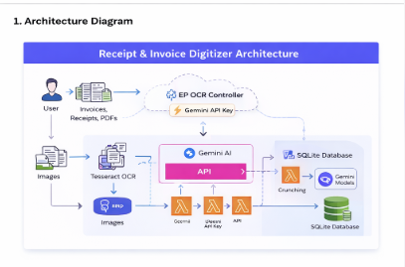
7.SYSTEM COMPONENTS
1. Frontend
- Streamlit UI
- Multiple pages via sidebar navigation:
  - Upload & Extract
  - Dashboard
  - History
2. OCR Layer
- Tesseract OCR extracts raw invoice text
- OCR improved using preprocessing:
  - resizing
  - CLAHE contrast enhancement
  - denoising
  - adaptive thresholding
  - morphological cleaning
3. AI Layer
- Gemini API converts OCR text into JSON format
- Handles:
  - vendor name
  - invoice date
  - items list
  - tax amount
  - currency
  - grand total
4. Database Layer
- SQLite vault.db stores:
  - invoice summary details
  - invoice items list

8.PROCESS FLOW (MILESTONE–1 WORKFLOW)
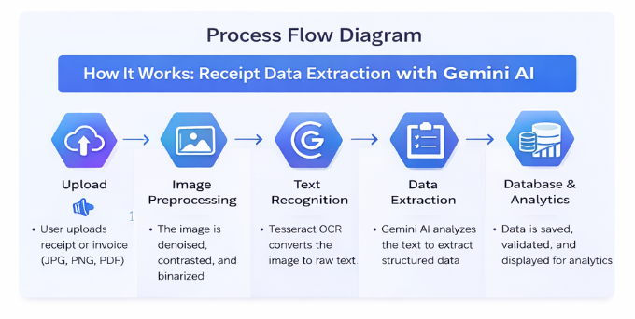
9.DATABASE SCHEMA (SQLite vault.db)
Table 1: invoices
Column Name | Type | Description
invoice_id | TEXT (PK) | Unique invoice identifier
vendor_name | TEXT | extracted shop/vendor name
date | TEXT | invoice date
total_amount | REAL | extracted bill total
raw_text | TEXT | full OCR extracted text
created_at | TEXT | timestamp when stored
category | TEXT | auto category (Dining/Shopping/etc)
currency | TEXT | INR/USD/EUR etc
tax_amount | REAL | tax extracted
items_sum | REAL | calculated items total
validation_status | TEXT | VALID / NOT_VALID

Table 2: items
Column Name | Type | Description
id | INTEGER PK | auto increment id
invoice_id | TEXT (FK) | maps to invoices.invoice_id
item_name | TEXT | extracted item name
quantity | INTEGER | item qty
price | REAL | item price

DB Migration Feature
migration to safely add missing columns.
Function:
- ensure_column_exists()

10.VALIDATION & DUPLICATE DETECTION

1) Validation Logic
Validation ensures correct invoice is stored.
Validation Conditions
Invoice is VALID when:
- Items list exists
- Items sum approximately equals total OR
- Items sum + tax ≈ total
Tolerance:
tol = max(2.0, total * 0.02)
If mismatch:
- invoice not saved
- shown as warning

2) Duplicate Detection
Duplicate check is done before saving.
Logic:
- compare first 200 characters of OCR raw_text
- match invoice already stored
Function:
- find_duplicate_invoice()
Query:
SELECT invoice_id FROM invoices
WHERE raw_text LIKE prefix%
LIMIT 1
If duplicate found:
- invoice_id returned
- system skips saving new entry

11.Outputs Generated
✅ Original Image
✅ Processed Image
✅ OCR Extracted Raw Text
✅ Structured JSON fields:
- invoice_id
- vendor_name
- items
- tax_amount
- total_amount
- currency
✅ Stored record in SQLite
✅ Dashboard charts and history table
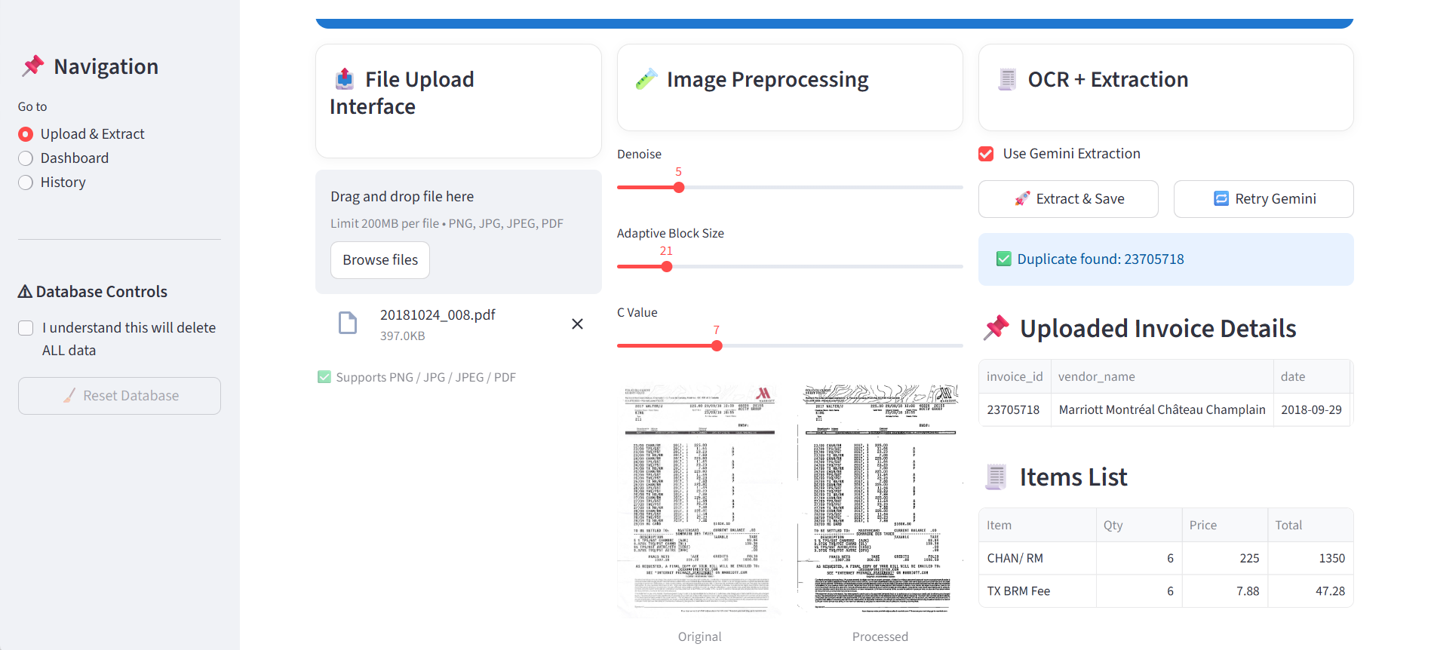
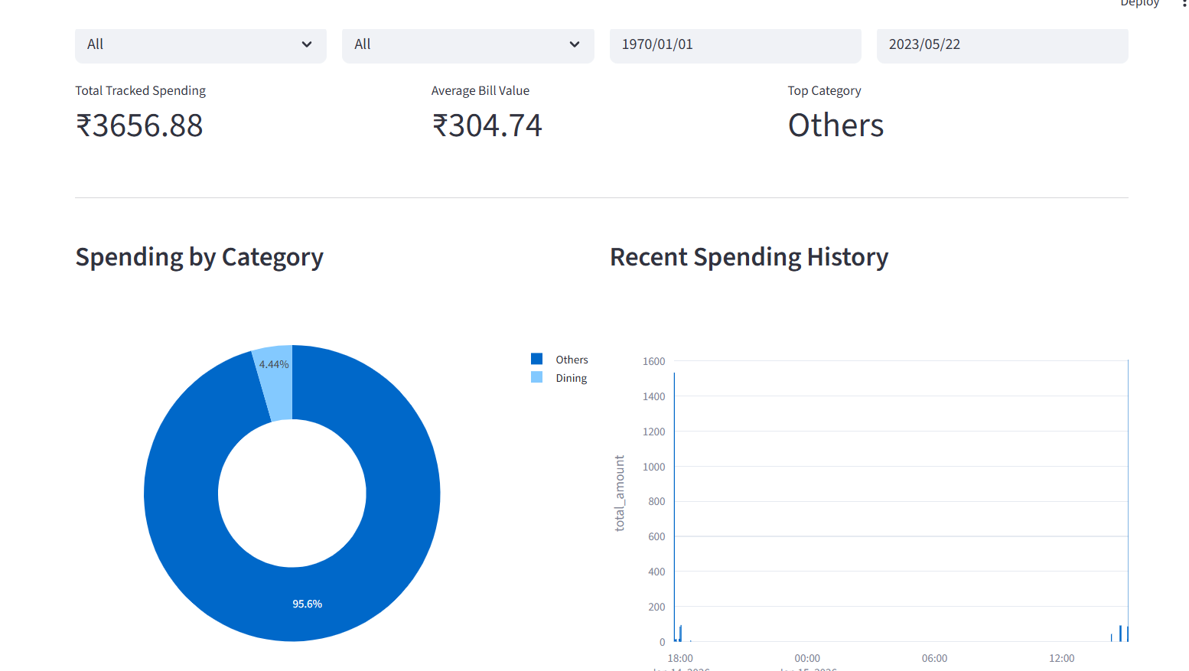
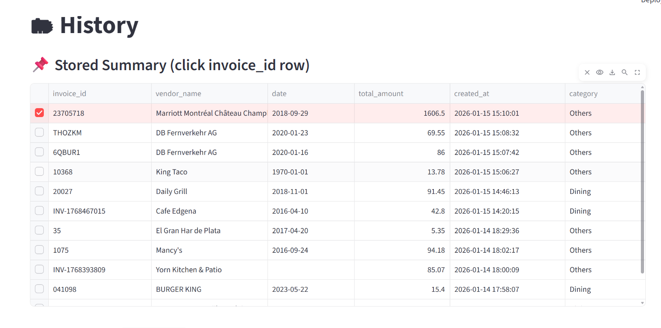

12. References
- Tesseract OCR
Smith, R. (2007). An overview of the Tesseract OCR engine. ICDAR, 629–633.
- OpenCV Image Processing Library
Bradski, G. (2000). The OpenCV Library. Dr. Dobb’s Journal.
- Streamlit Framework
Streamlit Inc. (2023). Streamlit: The fastest way to build data apps in Python.
- SQLite Database
Hipp, D. R. (2023). SQLite.
- PyMuPDF / fitz PDF parser
Used for multi-page PDF extraction into images.
- Google Gemini API
Used for generating structured JSON from OCR text.

